**PROGRAMMING REFRESHER**

1) Variables

Variables are elements which are assigned a particular value. They reserve memory locations to store value.

Programming question: Write a Python Program to print values 2 and 3.

Code :

a=2;

b=3;

print(a);

print(b);

Output:

2  
3

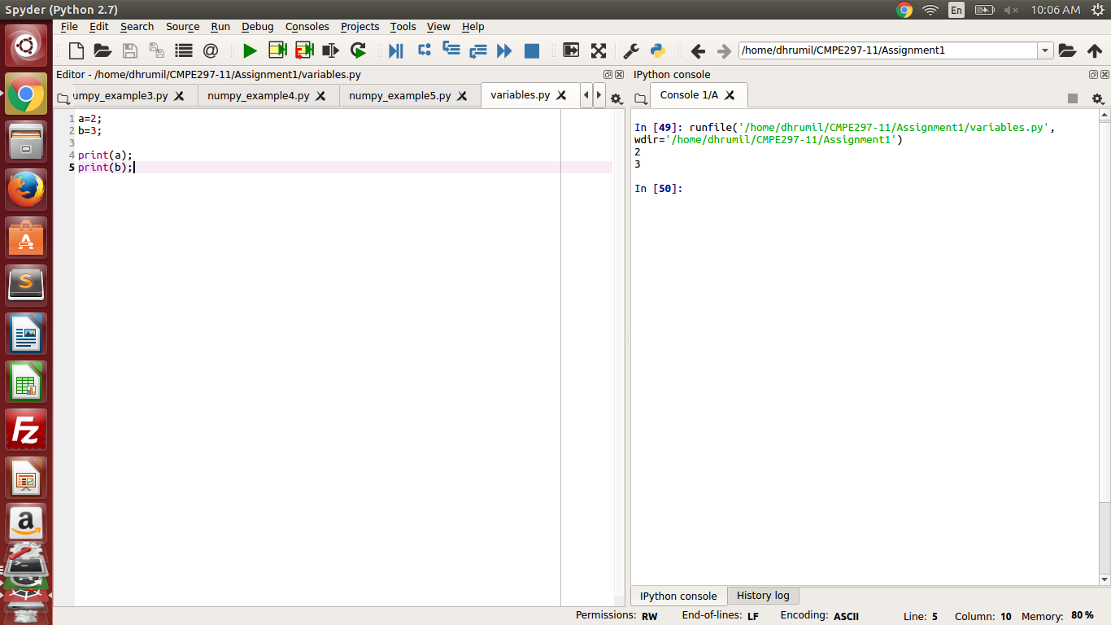

2) Objects

Objects refer to an instance of class. It is a location in memory having a value and it can be a variable, a function or a method.

Programming question: Write a python program to call a function in class through an object.

Code : class basic:

def function(self):

print ("this is called from a function")

object1=basic(); #object of class "basic" is created

object1.function() #function called with the help of object

Output:

this is called from a function

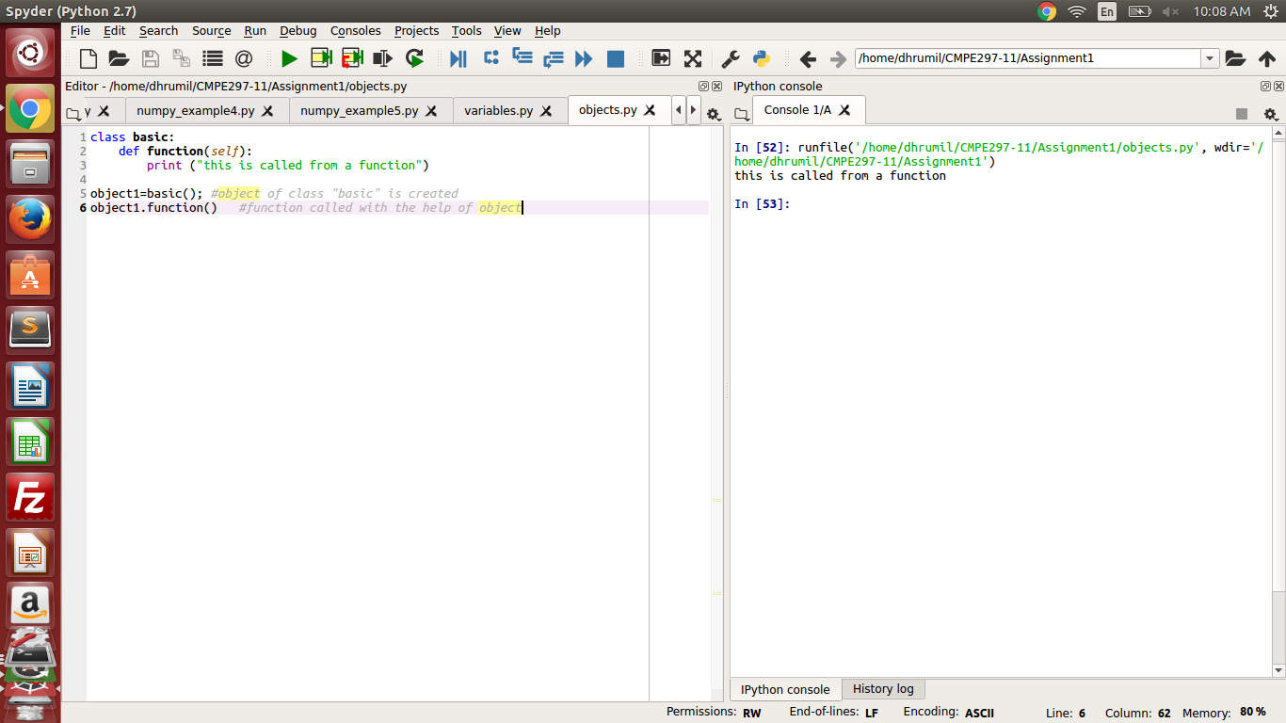

3) Function

Function is a procedure through which a specific task is accomplished. In Python functions are defined by "def" keyword.

Programming question:

Write a Python program to add two numbers.

Code:  
def sum(a,b): # function to add two numbers

c = a + b

print c

sum(2,3)

Output:

5

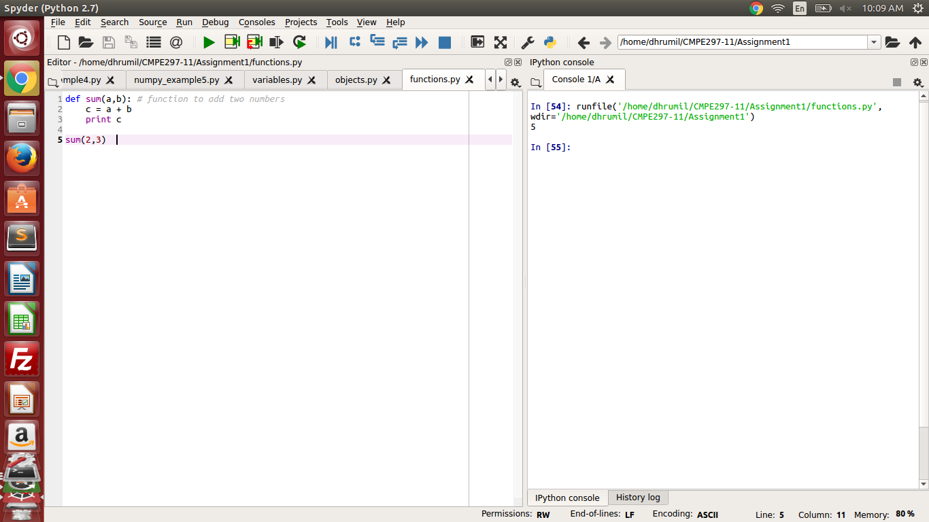

4) Events

Events are used to communicate between threads. They are responsible for synchronizing two or more thread operations.

Programming Question:

Write a Python program to create 4 threads and use event's wait and set function to handle those threads.

Code:

import threading #library for the thread and events

e = threading.Event() #event is created

thread = [] # array of threads

#function to handle the threads

def main_thread():

thread_name = threading.current_thread().name

print 'Thread waiting for event: %s' % thread_name

e.wait(3) #waits for 3 seconds

print 'Thread got event: %s' % thread_name

e.set() #thread is set

print 'Thread set: %s' % thread_name

for threads in range(4):

threads = threading.Thread(target=main_thread)

thread.append(threads)

threads.start() # creates the thread and calls the "main_thread" function

Output:

Thread waiting for event: Thread-16  
Thread waiting for event: Thread-17  
Thread waiting for event: Thread-18Thread waiting for event: Thread-19

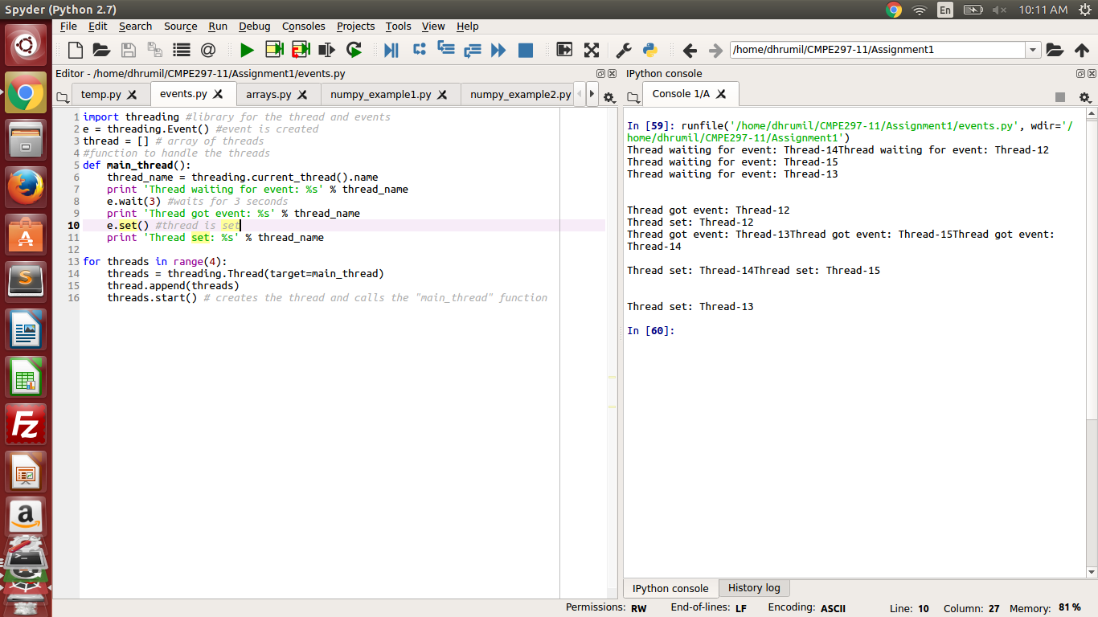

The above image shows the response when thread waits for 3 seconds.

Thread waiting for event: Thread-16  
Thread waiting for event: Thread-17  
Thread waiting for event: Thread-18Thread waiting for event: Thread-19  
  
Thread got event: Thread-16  
Thread set: Thread-16  
Thread got event: Thread-17  
Thread set: Thread-17  
Thread got event: Thread-19Thread got event: Thread-18  
  
Thread set: Thread-18Thread set: Thread-19

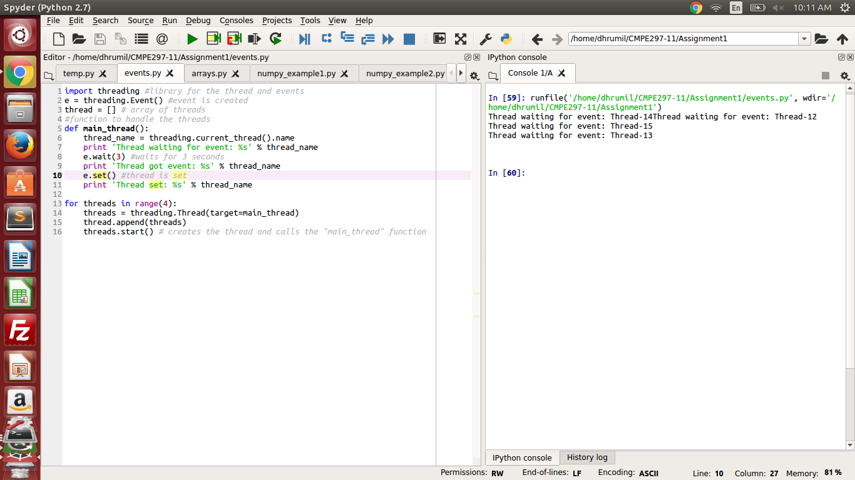

The above image shows the response after 3 seconds.

5) Arrays

An array is a data structure which stores all the values of same data type.

Programming Question:

Create an array in Python and print all the values of array.

Code: a=[1,2,3,4,5]

for i in range(len(a)):

print(a[i])

Output:

1  
2  
3  
4  
5

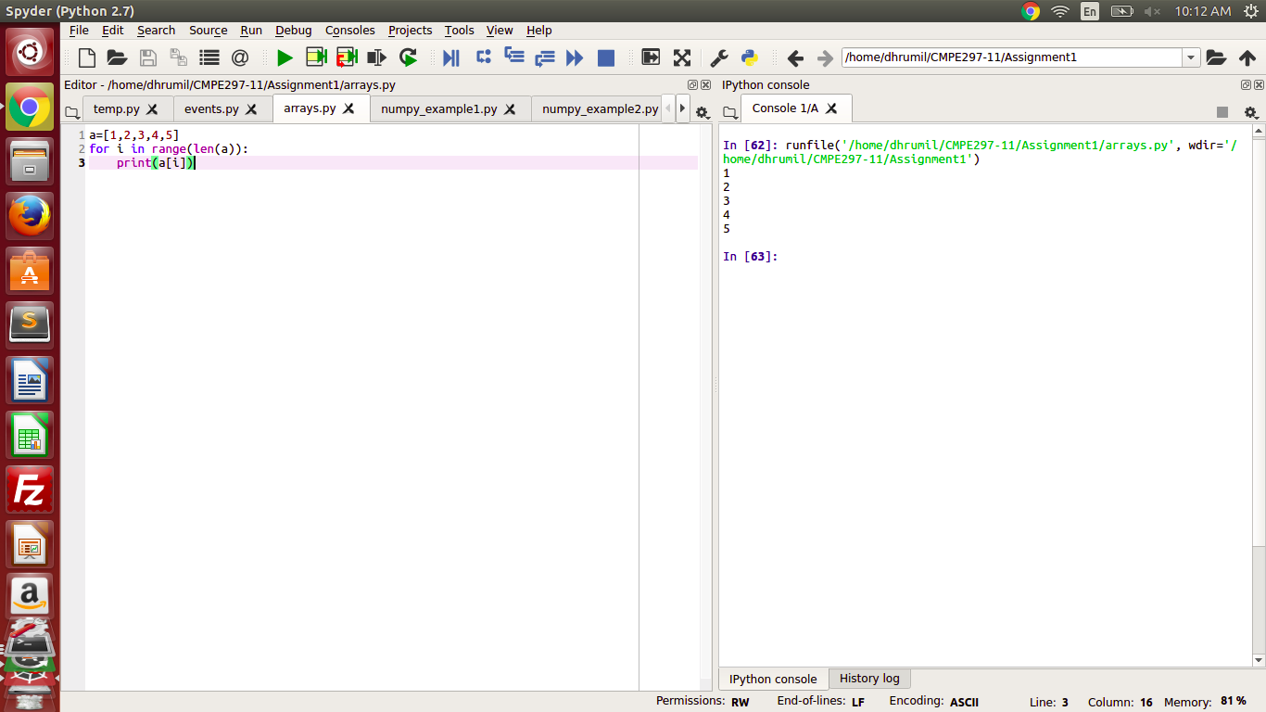

6) Conditions

Condition consists of group of statements and it gives different output according to the input given by the user.

Programming Question:

Write a Python program to check whether a given number is less than, equal to or greater than 10.

Code: a=10;

if(a <10): #evaluated when input is less than 10

print "a is less than 10"

elif( a ==10): #evaluated when input equals 10

print "a is equal to 10"

else: #evaulated when input is greater than 10

print "a is greater than 10"

Output:

a is equal to 10

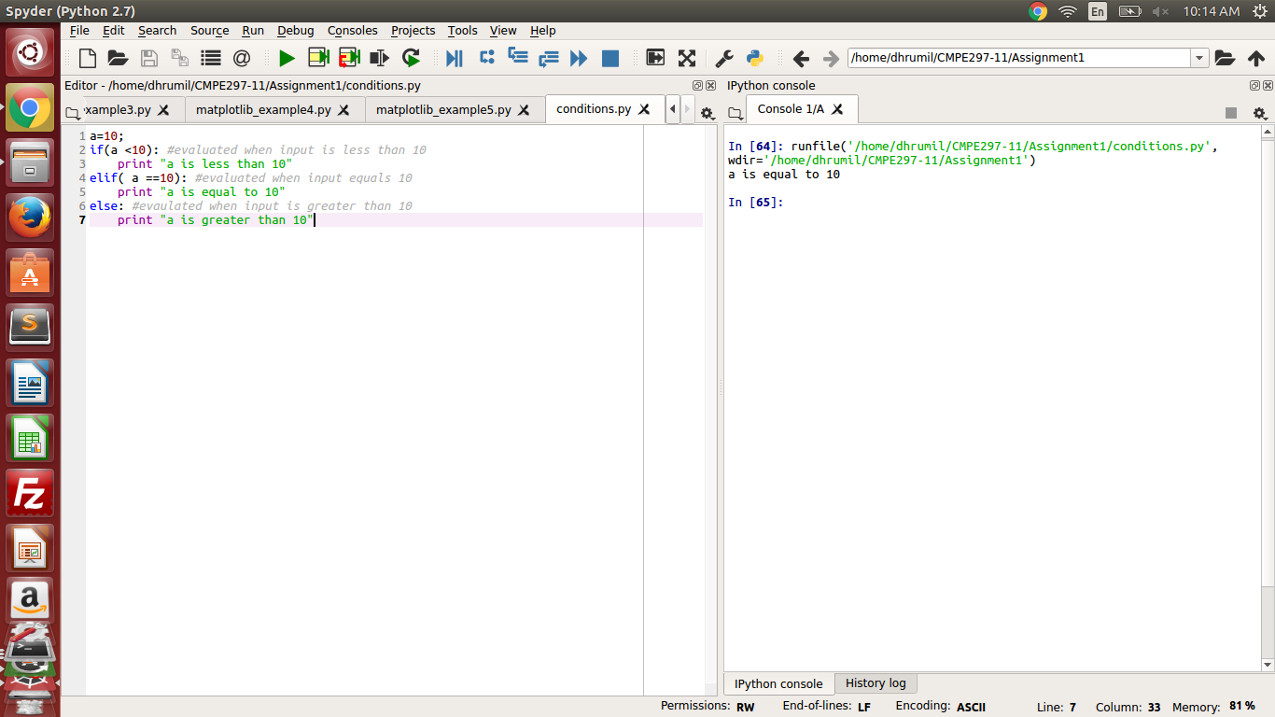

7) Errors

Errors are any types of issues which prevents the program from getting the desired output.

Programming Question : Write a Python program to demonstrate syntax error and logical error

def func(a,b):

print(a + b) #**syntax error** due to indentation

a=1

b=2

func(a,b)

Output:

File "<ipython-input-63-4eb80a0a43fb>", line 2  
 print(a + b) #syntax error due to indentation  
 ^  
IndentationError: expected an indented block

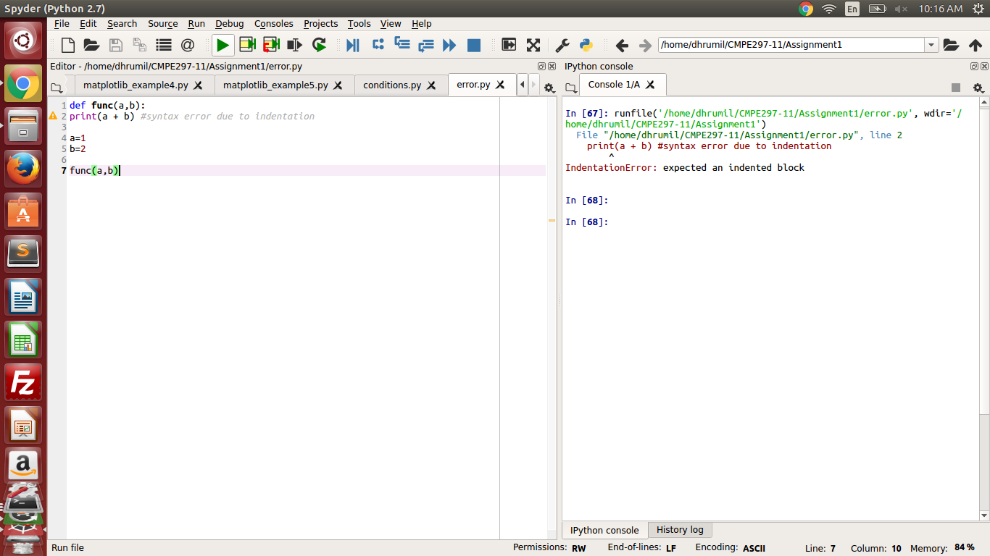

The above code shows the **syntax error.**

a=100

b=100

if( a < b):

print "a is less than b"

else:

print " a is greater than b" #logical error as it prints "a is greater than b" even though a=b

Output:

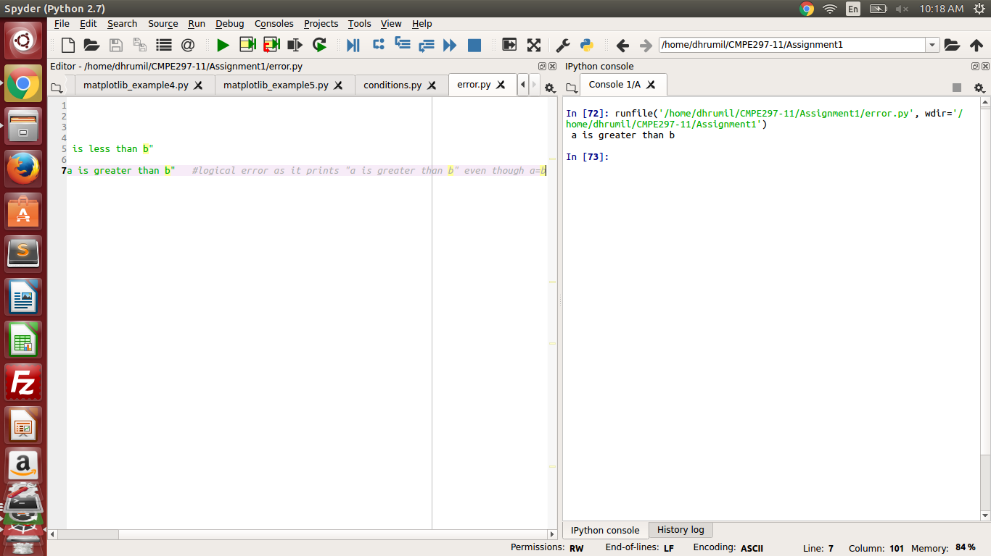

The above code shows the logical error.

8) Type Conversions

Type conversion is basically changing a variable's data type. For example, changing integer data type to float.

Programming Question: Write a Python Program to demonstrate type conversion in python.

Code:

string = "100"

integer= int("100")

bases=int(string,2) # converted the string to base 2

decimal= 3

decimal= float(integer) #type casted from integer to float

print(integer)

print(decimal)

print(bases)

Output:

100  
100.0  
4

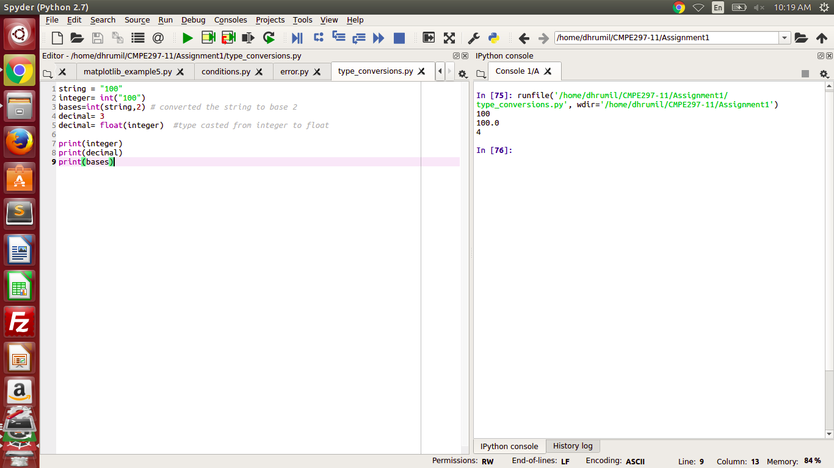

9) Numpy Library

Numpy is a package for performing scientific computation in Python. It is mainly used for performing operations on multi dimensional arrays and matrices

Programming Question 1: Write a Python program to declare array with numpy library

Code: import numpy as np

arr=np.array([1,2,3,4]) #declaring array with numpy

print(arr)

Output:

[1 2 3 4]

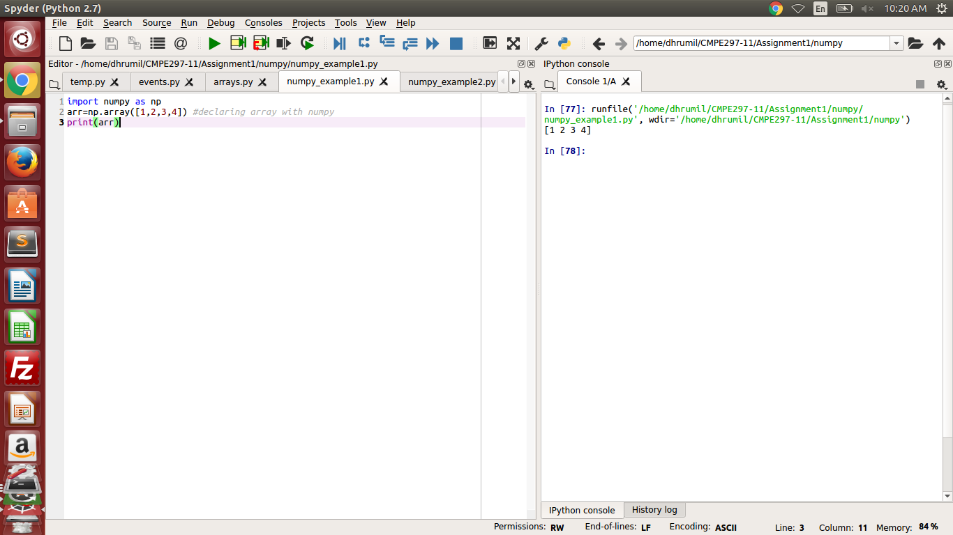

Programming Question 2: Write a Python Program to shape and reshape arrays using numpy library.

Code:

import numpy as np

a = np.arange(24)

print a

print a.shape

b = a.reshape(2,4,3) #reshaped array

print b

Output:

[ 0 1 2 3 4 5 6 7 8 9 10 11 12 13 14 15 16 17 18 19 20 21 22 23]  
(24,)  
[[[ 0 1 2]  
 [ 3 4 5]  
 [ 6 7 8]  
 [ 9 10 11]]  
  
 [[12 13 14]  
 [15 16 17]  
 [18 19 20]  
 [21 22 23]]]

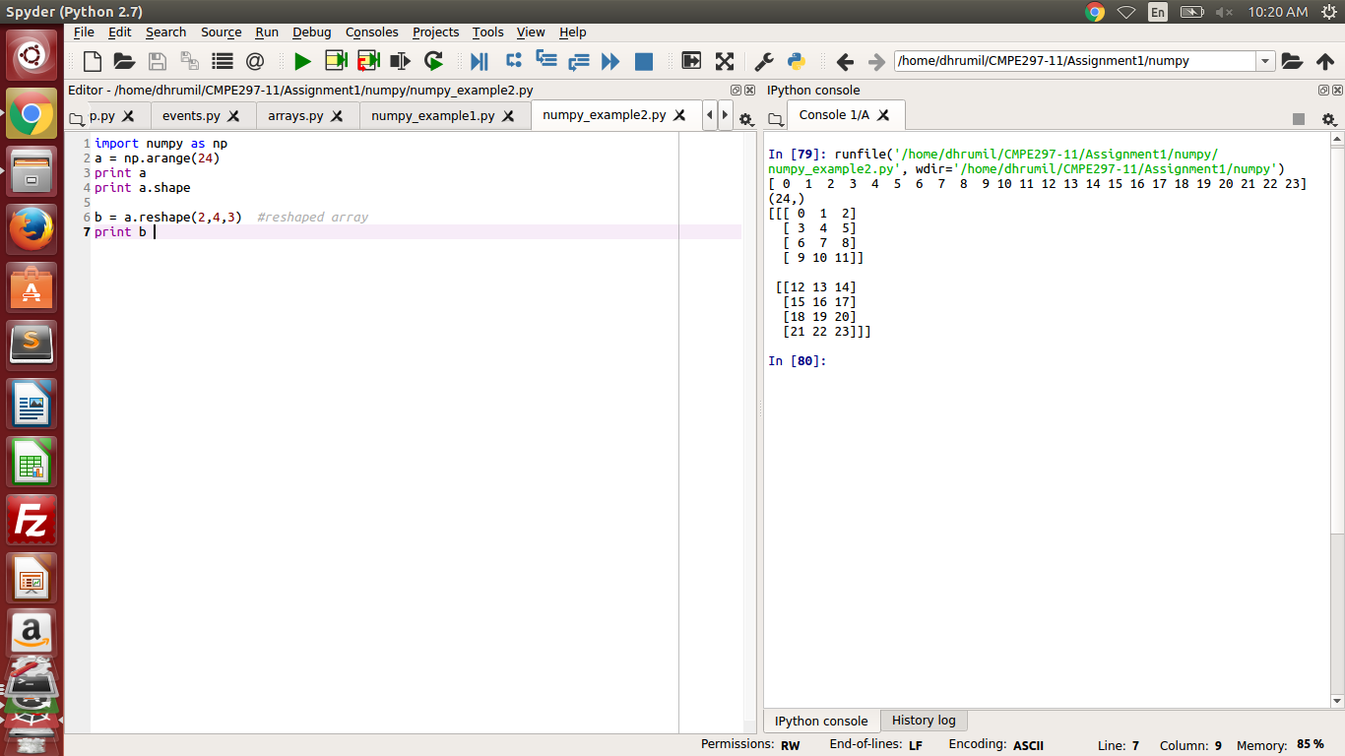

Programming Question 3: Write a Python program to calculate the sum of two arrays of different sizes.

Code:

import numpy as np

first = np.array([[0.0,1.0,2.0],[6.0,7.0,8.0]])

second = np.array([1.0,2.0,3.0])

print ' First Array'

print first

print 'Second Array'

print second

print 'resultant array'

print first + second

Output:

First Array  
[[ 0. 1. 2.]  
 [ 6. 7. 8.]]  
Second Array  
[ 1. 2. 3.]  
resultant array  
[[ 1. 3. 5.]  
 [ 7. 9. 11.]]

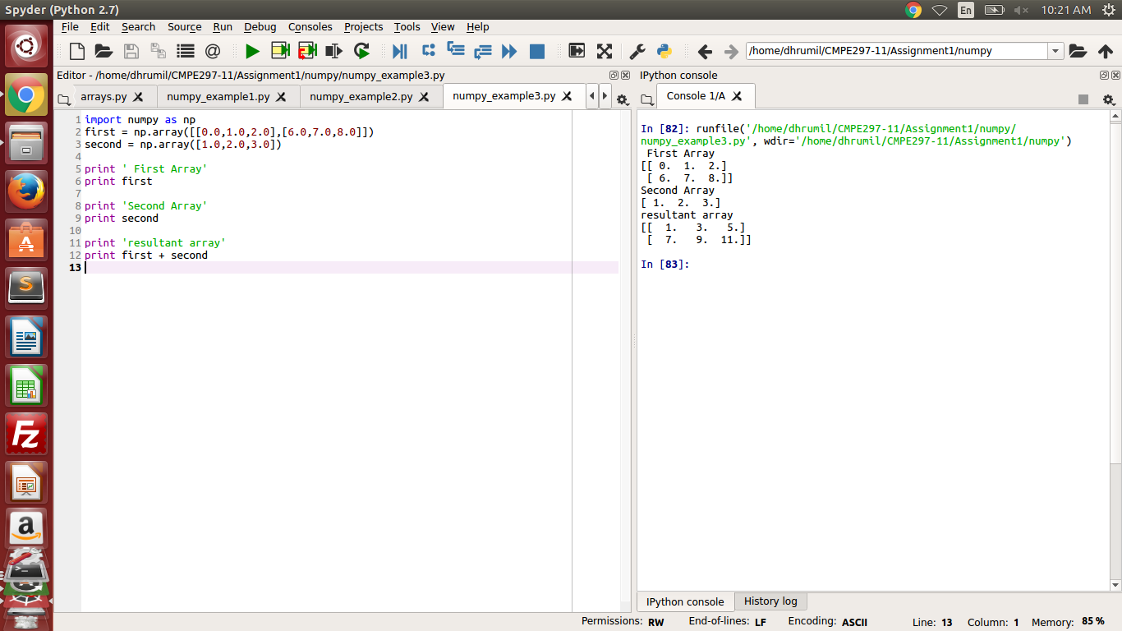

Programming Question 4: Write a program to slice the array using numpy library.

Code :

import numpy as np

a = np.array([[3,4,5],[6,7,8],[1,2,3]])

print 'Original array:'

print a

z = a[1:4,1:3]

y = a[2:3,[1,2]]

print 'Array after Slicing'

print y

Output:

Original array:  
[[3 4 5]  
 [6 7 8]  
 [1 2 3]]  
Array after Slicing  
[[2 3]]

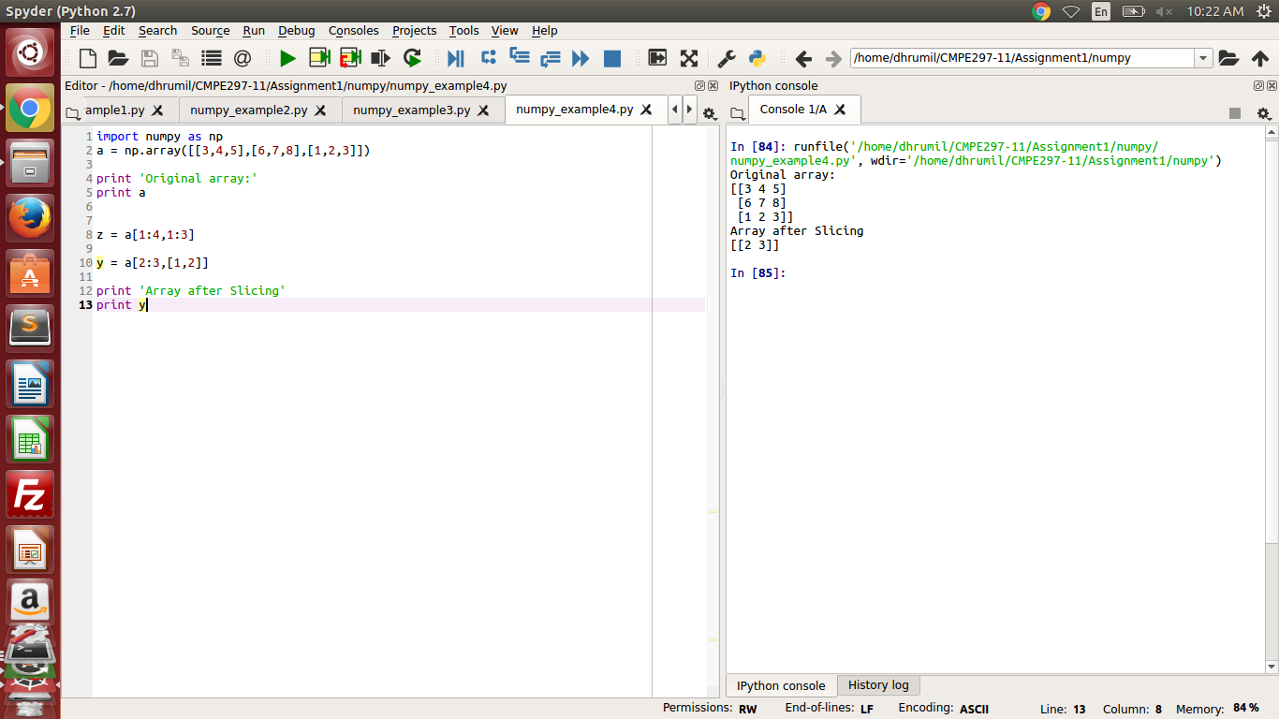

Programming Question 5: Write a Python program to compute the trigonometric ratios of given angles

Code:

import numpy as np

arr = np.array([0,30,45,60,90,120,135,150,180])

print 'Sine value of the angles'

print np.sin(arr*np.pi/180)

print 'Cosine values of the given angles'

print np.cos(arr*np.pi/180)

print 'Tangent values of given values'

print np.tan(arr*np.pi/180)

Output:

Sine value of the angles  
[ 0.00000000e+00 5.00000000e-01 7.07106781e-01 8.66025404e-01  
 1.00000000e+00 8.66025404e-01 7.07106781e-01 5.00000000e-01  
 1.22464680e-16]  
Cosine values of the given angles  
[ 1.00000000e+00 8.66025404e-01 7.07106781e-01 5.00000000e-01  
 6.12323400e-17 -5.00000000e-01 -7.07106781e-01 -8.66025404e-01  
 -1.00000000e+00]  
Tangent values of given values  
[ 0.00000000e+00 5.77350269e-01 1.00000000e+00 1.73205081e+00  
 1.63312394e+16 -1.73205081e+00 -1.00000000e+00 -5.77350269e-01  
 -1.22464680e-16]

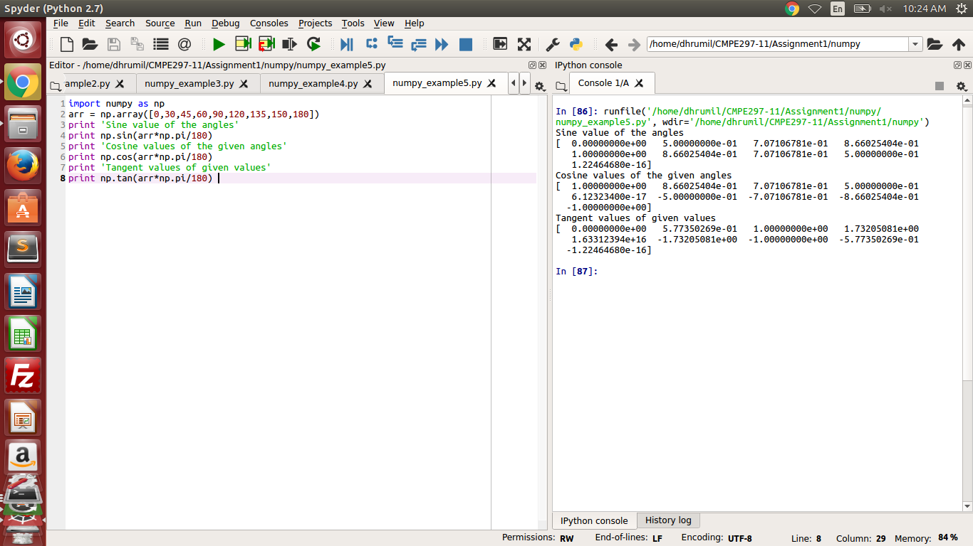

10) Pandas Library

Pandas is a library which provides high performance data structures and data analysis tools for Python Programming Language.

Programming Question 1: Write a Python program to create series using pandas library

Code:

import pandas as pd

import numpy as np

a = np.array(['a','b','c','d'])

s = pd.Series(a)

print s

Output:

0 a  
1 b  
2 c  
3 d  
dtype: object

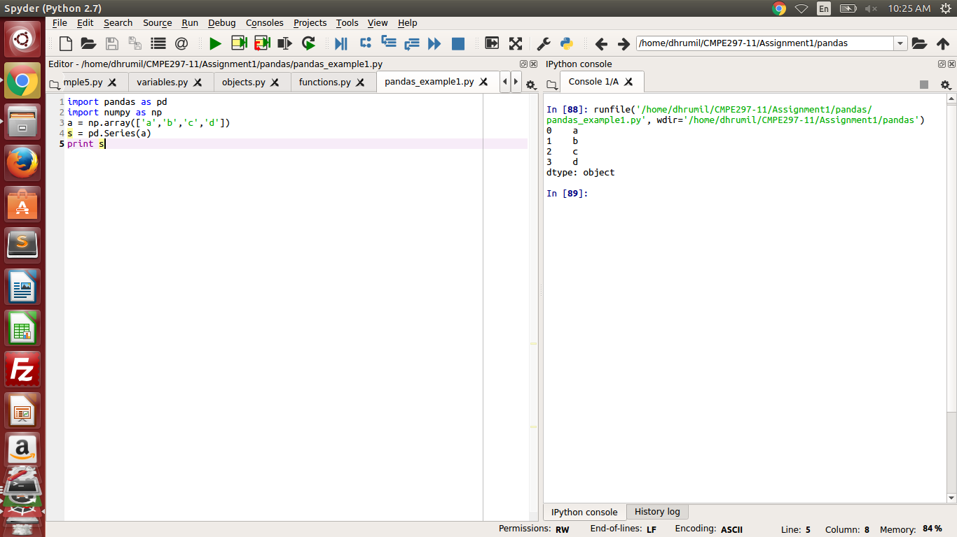

Programming Question 2: Write a Python Program to draw a table with three columns "student id", "name" and "age".

Code:

import pandas as pd

arr=[[123,'Andrew',15],[456,'Mike',17],[789,'John',16]]

df = pd.DataFrame(arr,columns=['Student Id','Name','Age'])

print df

Output:

Student Id Name Age  
0 123 Andrew 15  
1 456 Mike 17  
2 789 John 16

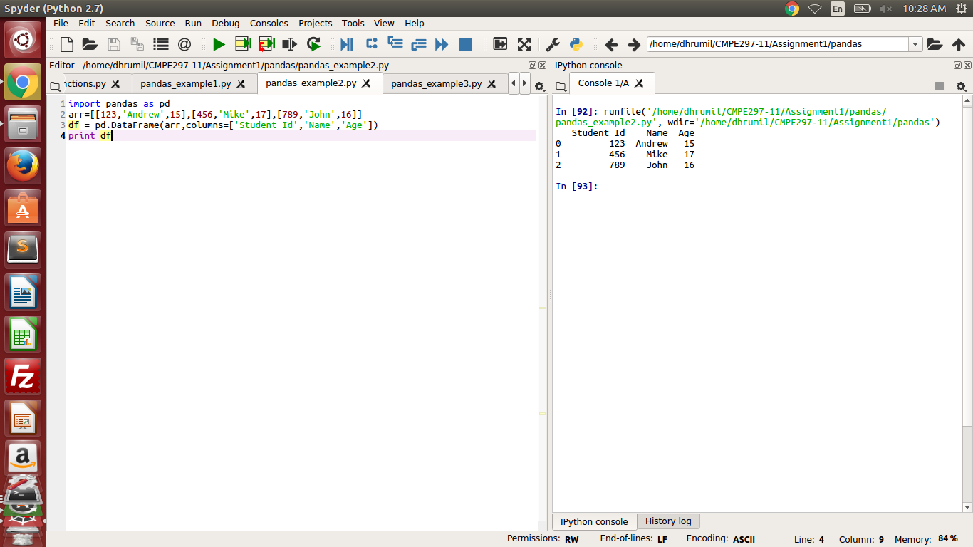

Programming Question 3: Write a Python Program to create a basic panel.

Code:

import pandas as pd

import numpy as np

panel = np.random.rand(1,2,3)

panel = pd.Panel(panel)

print panel

Output:

<class 'pandas.core.panel.Panel'>  
Dimensions: 1 (items) x 2 (major_axis) x 3 (minor_axis)  
Items axis: 0 to 0  
Major_axis axis: 0 to 1  
Minor_axis axis: 0 to 2

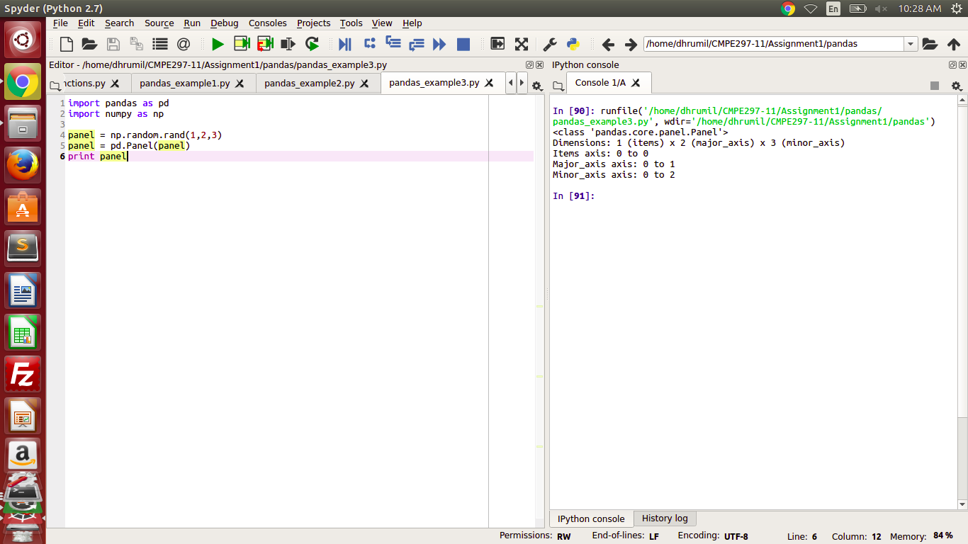

Programming Question 4: Take the data from question 2, and sort the values with respect to columns "Student ID", "Name" and "Age"

Code:

import pandas as pd

unsorted_data = pd.DataFrame({'student_id':[123,456,789],'Name':['Andrew','Mike','John'],'Age':[15,17,16]})

sorted_data_age = unsorted_data.sort_values(by='Age') #sorted according to age

sorted_data_name = unsorted_data.sort_values(by='Name') #sorted according to Name

sorted_data_studentid = unsorted_data.sort_values(by='student_id') #sorted according to student id

print "Sorted Data according to Age"

print sorted_data_age

print " "

print "Sorted Data according to Name"

print sorted_data_name

print " "

print "Sorted Data according to Student Id"

print sorted_data_studentid

Output:

Sorted Data according to Age  
 Age Name student_id  
0 15 Andrew 123  
2 16 John 789  
1 17 Mike 456  
   
Sorted Data according to Name  
 Age Name student_id  
0 15 Andrew 123  
2 16 John 789  
1 17 Mike 456  
   
Sorted Data according to Student Id  
 Age Name student_id  
0 15 Andrew 123  
1 17 Mike 456  
2 16 John 789

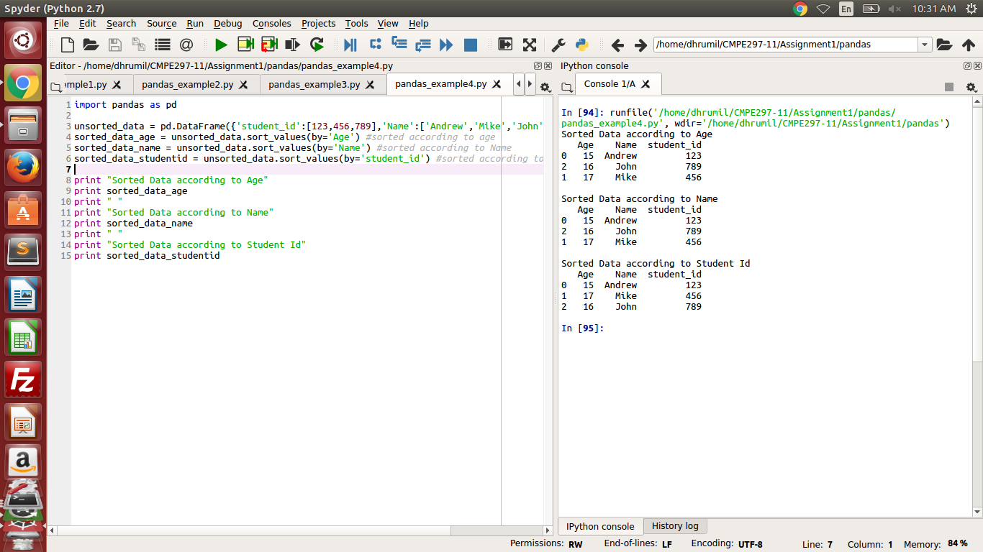

Programming Question 5: Using the same data in the previous question, use the describe method for the dataframes and watch the output.

Code:

import pandas as pd

unsorted_data = pd.DataFrame({'student_id':[123,456,789],'Name':['Andrew','Mike','John'],'Age':[15,17,16]})

sorted_data = unsorted_data.sort_values(by='Age').sum();

print unsorted_data.describe();

Output:

Age student_id  
count 3.0 3.0  
mean 16.0 456.0  
std 1.0 333.0  
min 15.0 123.0  
25% 15.5 289.5  
50% 16.0 456.0  
75% 16.5 622.5  
max 17.0 789.0

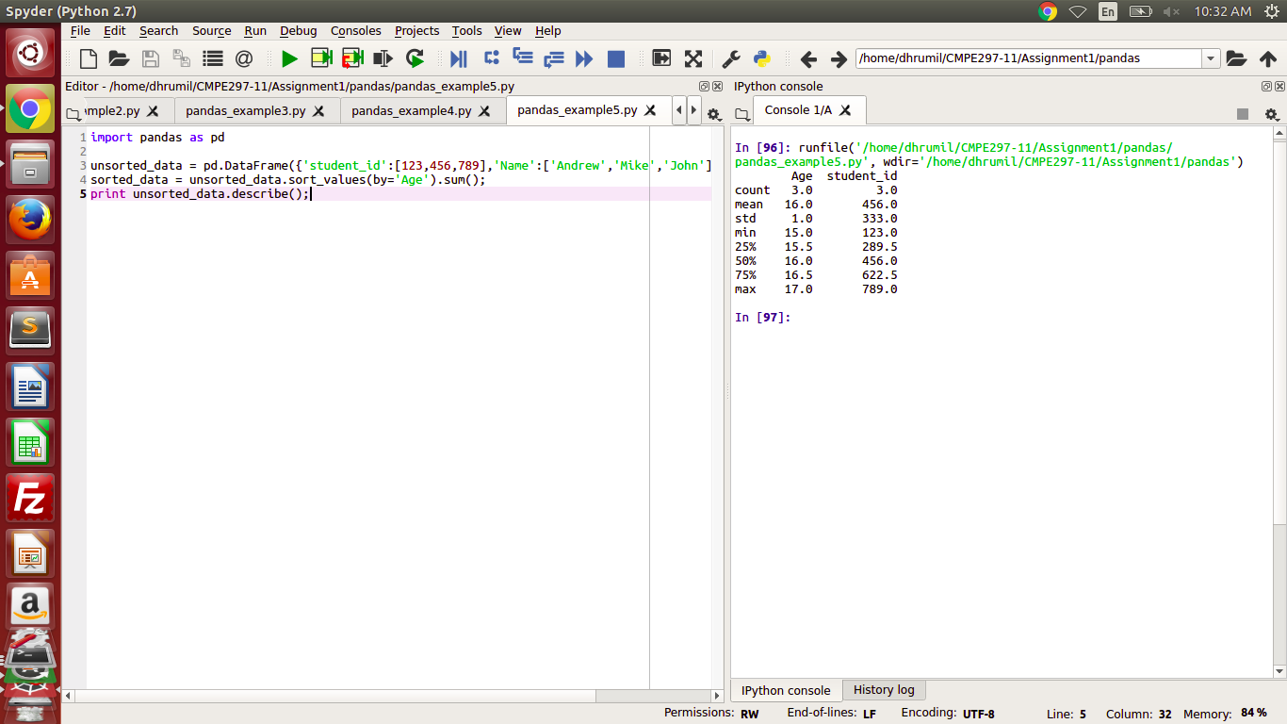

11) Matplotlib Lirary

Matplotlib Library is plotting library for Python.

Programming Question 1: Plot a straight line of equation y= 3 * x;

Code :

import numpy as np

from matplotlib import pyplot as plt

x = np.arange(1,5)

y = 3 * x

plt.title("Matplotlib example 1")

plt.xlabel("x axis")

plt.ylabel("y axis")

plt.plot(x,y)

plt.show()

Output:

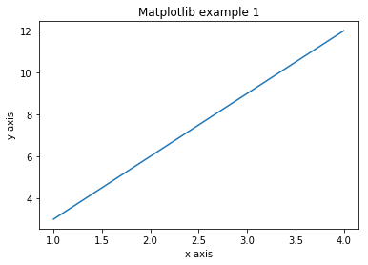

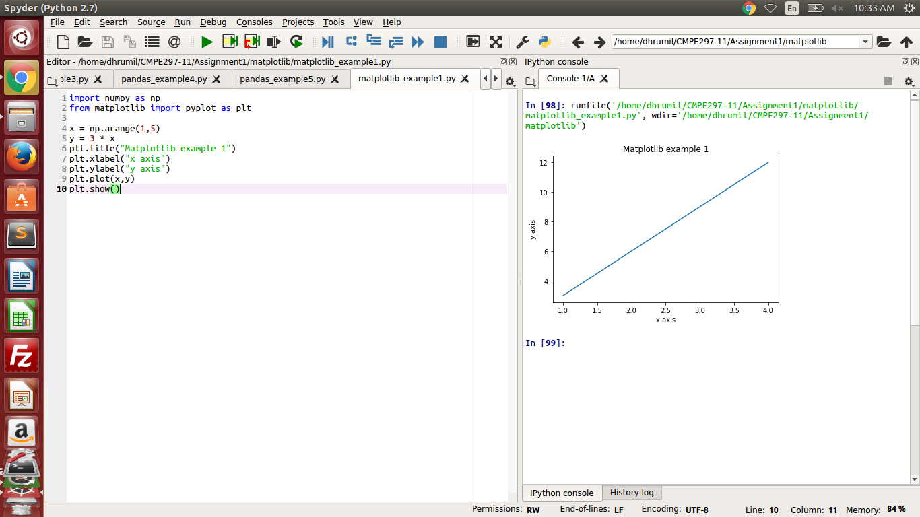

Programming Question 2: Create a histogram using matplotlib library.

Code:

from matplotlib import pyplot as plt

import numpy as np

from random import randint

a=np.array([]);

for i in range(1,11):

r=randint(1,50)

a=np.append(a,r)

print a

plt.hist(a, bins = [0,10,20,30,40,50])

plt.title("histogram sample matlplotlib")

plt.show()

Output:

[ 6. 46. 40. 12. 40. 34. 25. 39. 5. 47.]

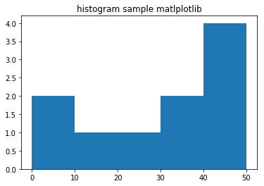

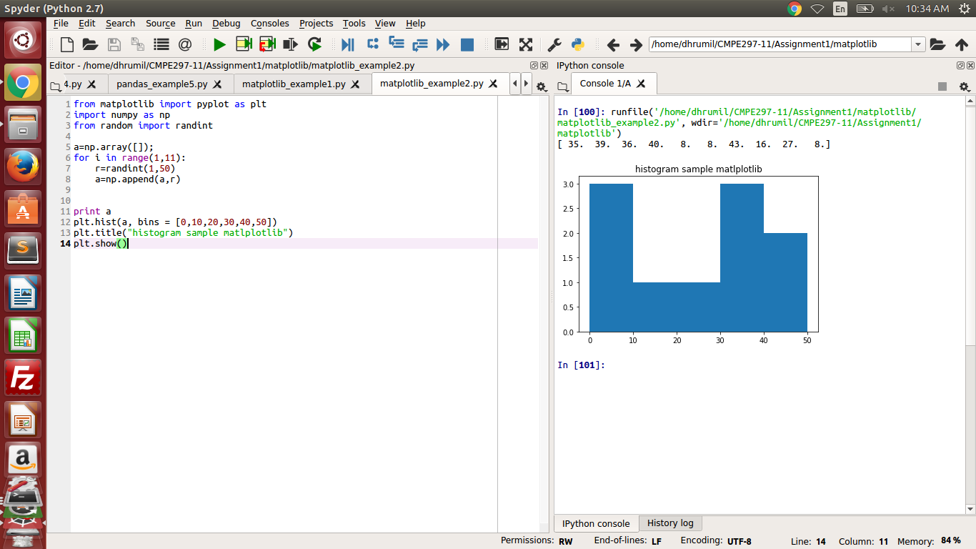

The output is different from the one above because random numbers are used to generate the histogram.

Programming Question 3: Plot a sine wave using matplotlib

Code:

import numpy as np

import matplotlib.pyplot as plt

plt.title("plottng a sine wave using matplotlib")

x_axis=np.arange(0,10, 0.1)

y_axis=np.sin(x_axis)

plt.plot(x_axis, y_axis)

plt.show()

Output:

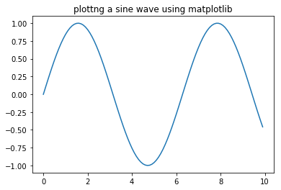

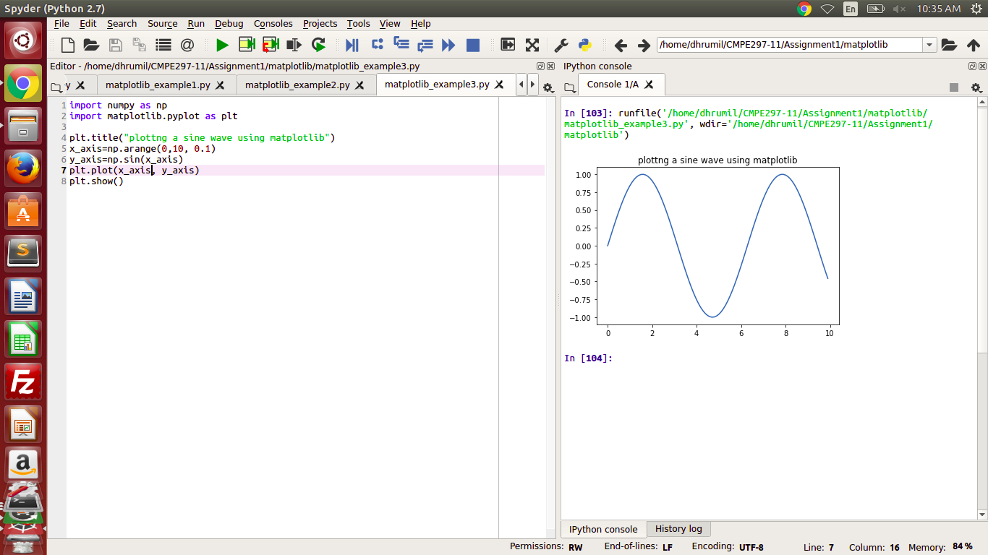

Programming Question 4: Create bar graph using matplotlib library

Code:

from matplotlib import pyplot as plt

z= [1,3,5]

y = [4,5,6]

plt.title('Bar graph plot using matplotlib')

x1 = [2,4,6]

y1 = [10,11,12]

plt.bar(z, y, color='r', align = 'center')

plt.bar(x1, y1, color = 'b', align = 'center')

plt.ylabel('Y axis')

plt.xlabel('X axis')

plt.show()

Output:

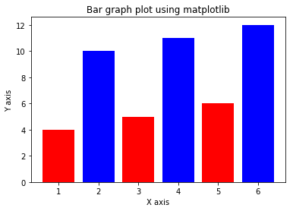

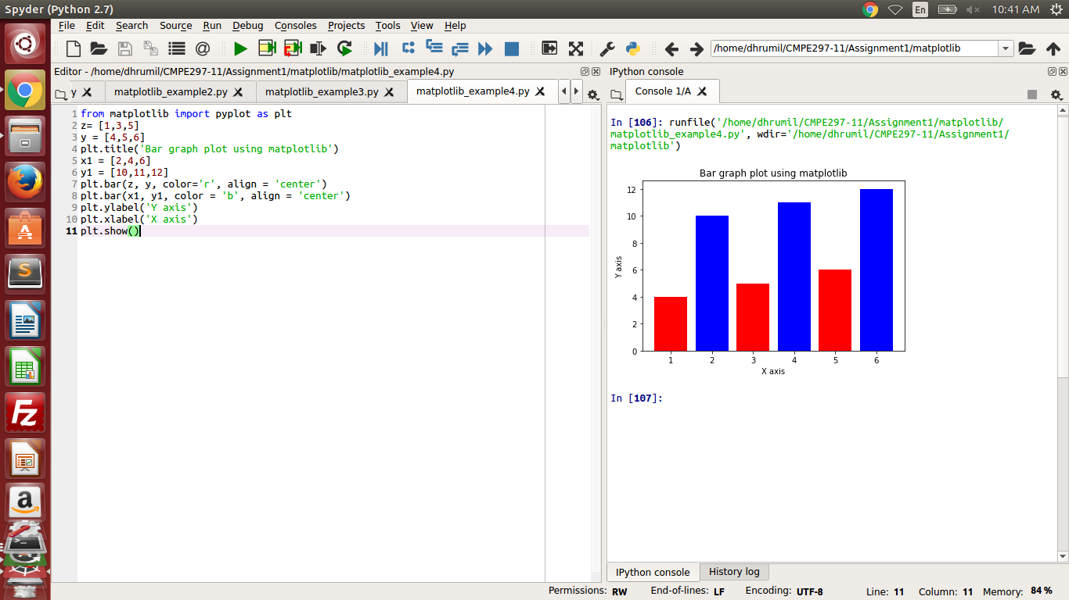

Programming Question 5: Using subplot function plot the sine, cosine and tangent wave.

Code:

import numpy as np

import matplotlib.pyplot as plt

x = np.arange(0,10, 0.1)

y_sin = np.sin(x)

y_cos = np.cos(x)

y_tan = np.tan(x)

plt.subplot(2,2,1)

plt.plot(x, y_sin)

plt.title('Sine wave in matplotlib')

plt.subplot(2,2,2)

plt.plot(x, y_cos)

plt.title('Cosine wave in matplotlib')

plt.subplot(2,2,3)

plt.plot(x, y_cos)

plt.title('Tangent wave in matplotlib')

plt.show()

Output:

